**1J1016/1J10164**

**SMD 2/4-Terminal 125 A Fixture**

**For use with 3265B DC Bias Unit**

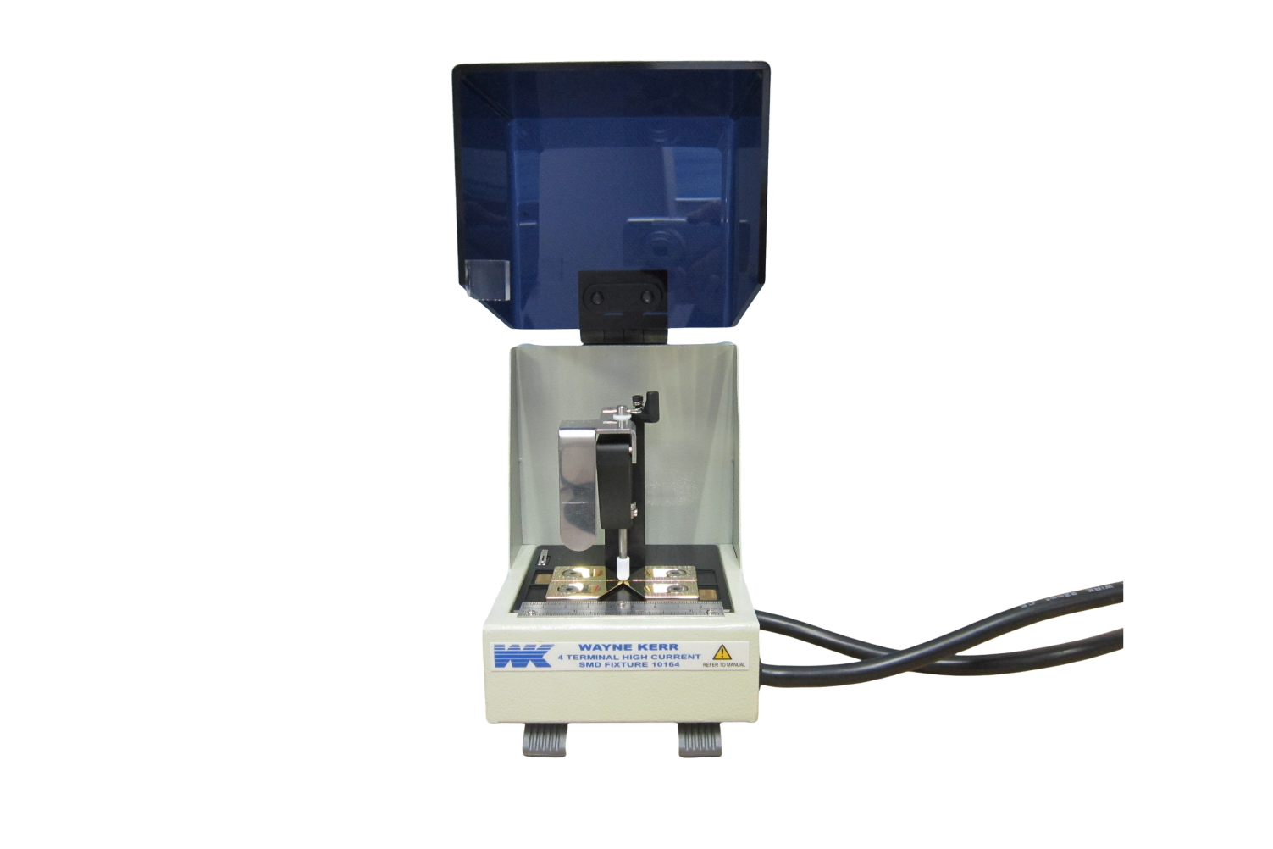

The 1J1016/1J10164 SMD 2/4-Terminal High Current Fixture is used to connect a Wayne Kerr Analyzer (3255B or 3260B) and DC Bias Unit (3265B) system to a surface mount Device Under Test and pass up to 125 A DC bias current.

**Suitable models**

The 1J1016 Fixture can be used with the following systems:

|  |  |  |  |
| --- | --- | --- | --- |
| **Analyzer** | **DC Bias Unit** | **Maximum measurement frequency** | **Maximum DC bias current** |
| 3255BL | 3265B | 200 kHz | 125 A using 5 units in parallel |
| 3255B | 500 kHz |
| 3255BQ | 1 MHz |
| 3260B | 3265B | 1 MHz | 125 A using 5 units in parallel |
| 3265BQ | 3 MHz | 50 A using 2 units in parallel |

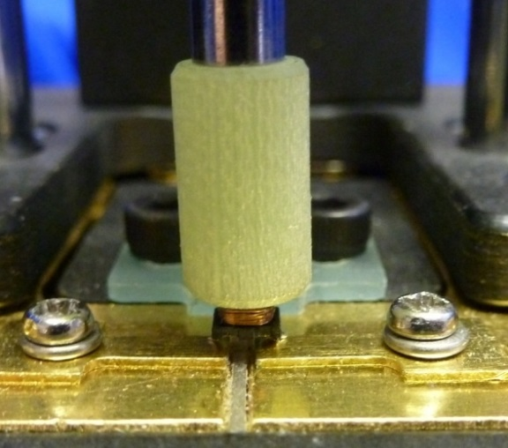

*Example of a wire wound surface mount choke being tested*

**Specification**

|  |  |
| --- | --- |
| Frequency Range: | 20 Hz to 3 MHz |
| DUT Max Temperature: | 200 ºC for 1 hour |
| Connections: | The measurement leads are connected to the analyzer (3255B/3260B) front panel BNC’s.  The high current leads are connected to the high current terminals of the 3265B DC Bias Unit.  2-terminal connection to the bottom face of Device Under Test. |
| DUT size: | DUT  40mm max  10mm max  18.8mm  max  1mm min |
| Safety: | When the fixture cover is opened, the safety interlock will operate and stop the DC bias current. |
| Dimensions: | 185 mm × 90 mm × 190 mm (L x W x H) |
| Weight: | 1.85 kg |